**Part 1 (Objective Type): Select all that are true.**

1. **Which of the following is equal to ?**
2. **Which Area represents ?**
3. 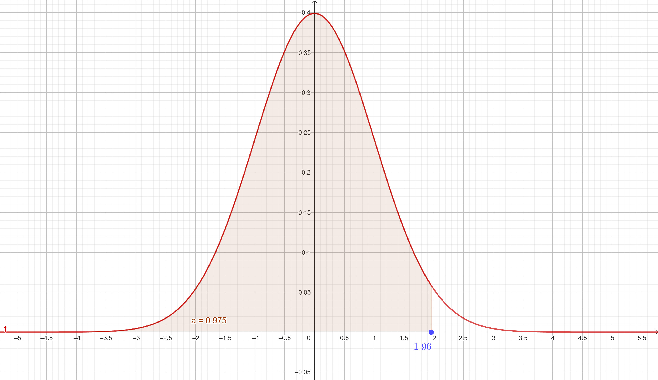
4. 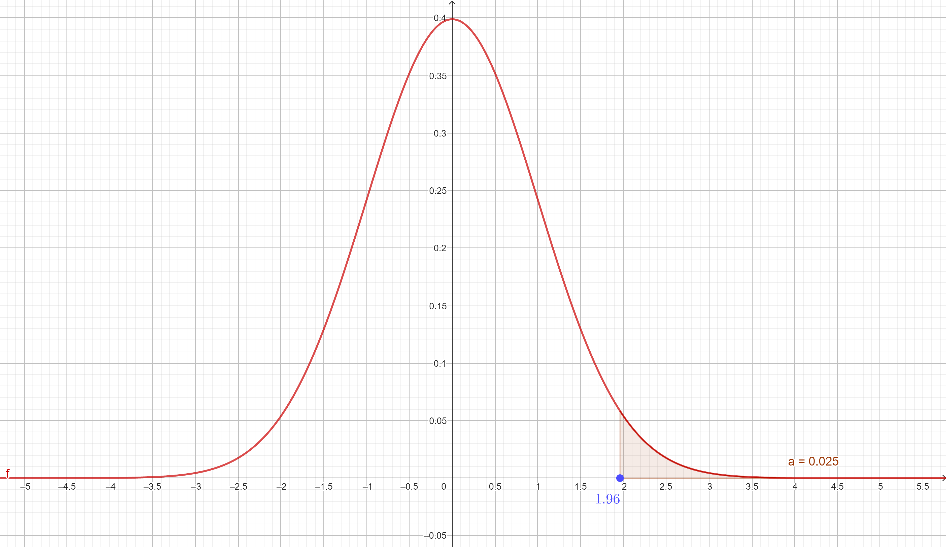
5. 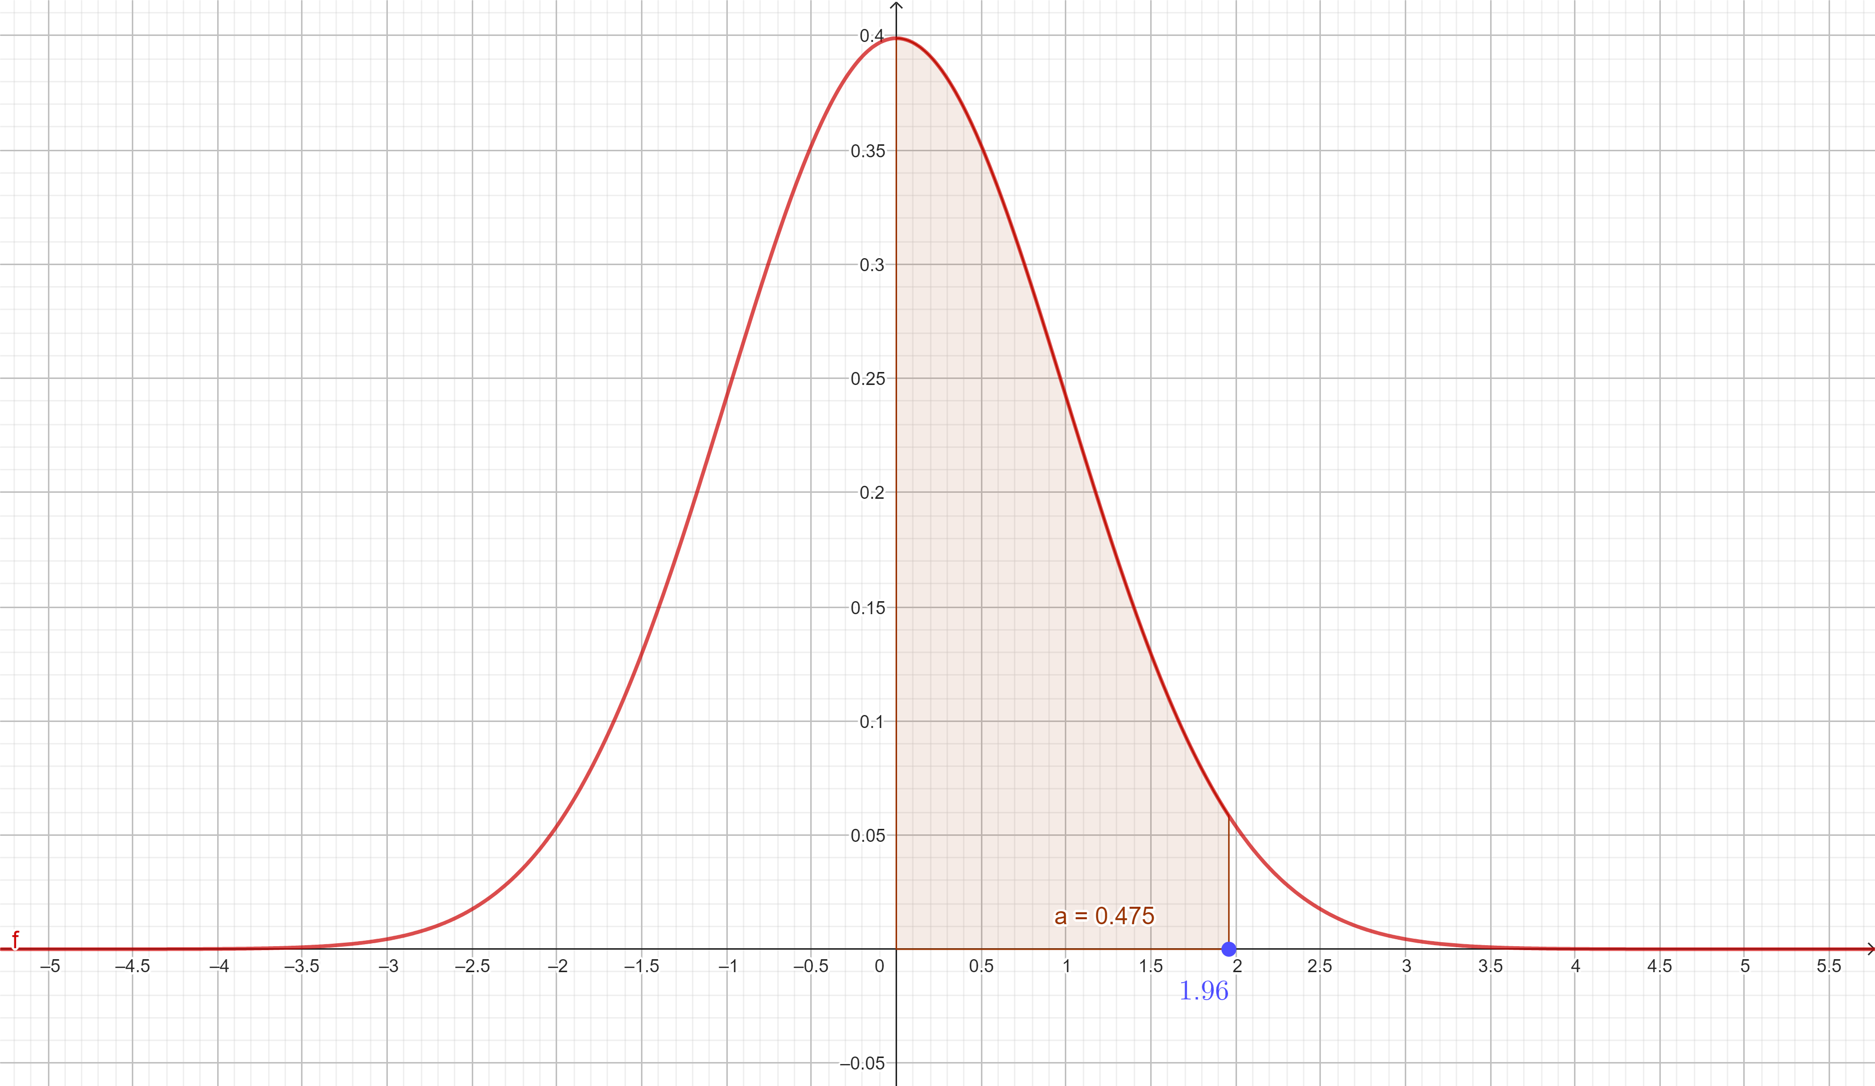
6. In CASIO Calculator, **MODE > STAT > AC > SHIFT > 1 > Distr > P(1.96)** , used for calculating which of the following area?
7. 
8. 
9. 
10. In CASIO Calculator, **MODE > STAT > AC > SHIFT > 1 > Distr > Q(1.96)** , used for calculating which of the following area?
11. A diagram of a normal distribution

    Description automatically generated
12. 
13. A graph of a function

    Description automatically generated
14. In CASIO Calculator, **MODE > STAT > AC > SHIFT > 1 > Distr > R(1.96)** , used for calculating which of the following area?
15. A diagram of a normal distribution

    Description automatically generated
16. 
17. A graph of a function

    Description automatically generated
18. Which of the following CASIO Function is equivalent to ?
19. **MODE > STAT > AC > SHIFT > 1 > Distr > R(2)**
20. **MODE > STAT > AC > SHIFT > 1 > Distr > P(2)**
21. **MODE > STAT > AC > SHIFT > 1 > Distr > Q(2)**
22. Which of the following CASIO Function is equivalent to ?
23. **MODE > STAT > AC > SHIFT > 1 > Distr > R(2)**
24. **MODE > STAT > AC > SHIFT > 1 > Distr > P(2)**
25. **MODE > STAT > AC > SHIFT > 1 > Distr > Q(2)**
26. Which of the following CASIO Function is equivalent to ?
27. **MODE > STAT > AC > SHIFT > 1 > Distr > R(2)**
28. **MODE > STAT > AC > SHIFT > 1 > Distr > P(2)**
29. **MODE > STAT > AC > SHIFT > 1 > Distr > Q(2)**
30. **Fill in the blanks.**
31. (b) (c)
32. **and must be calculated through ___________ when we are using statistical tables for standard normal distribution instead of using direct calculations from machine or evaluating definite integral.**
33. Iteration
34. Interpolation
35. Simulation
36. Binomial Theorem